**Queries:**

After loading all provided csv files execute following queries

1. Create relationship between parks and state  
     
   Match (a:Parks),(b:Parks)  
   where a.State = b.StateID  
   create (a)-[r:LOCATED_IN]->(b)  
   return r

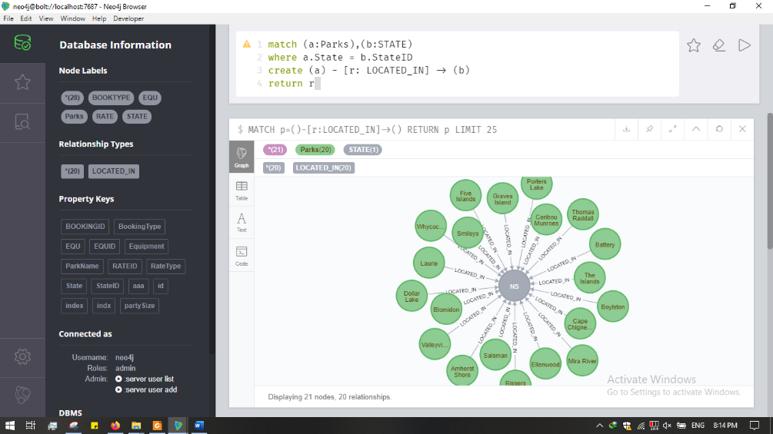

1. Create relationship between parks and equipment  
     
   Match (a:Parks),(b:EQU)  
   where a.Equipment = b.EQUID   
   create (a)-[r:TYPE_EQU]->(b)  
   return r

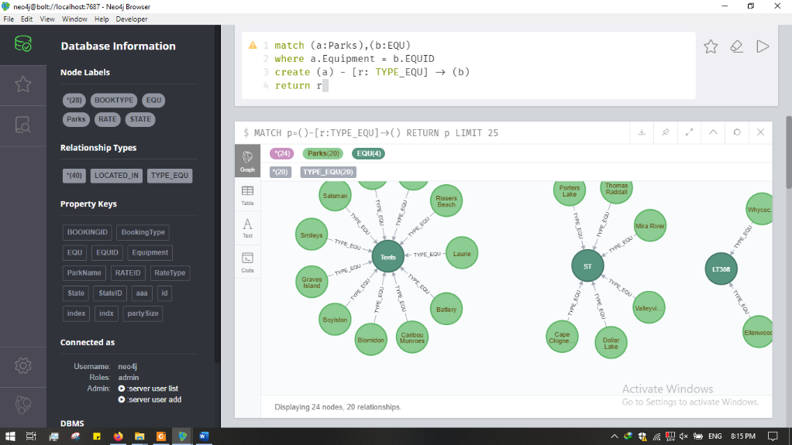

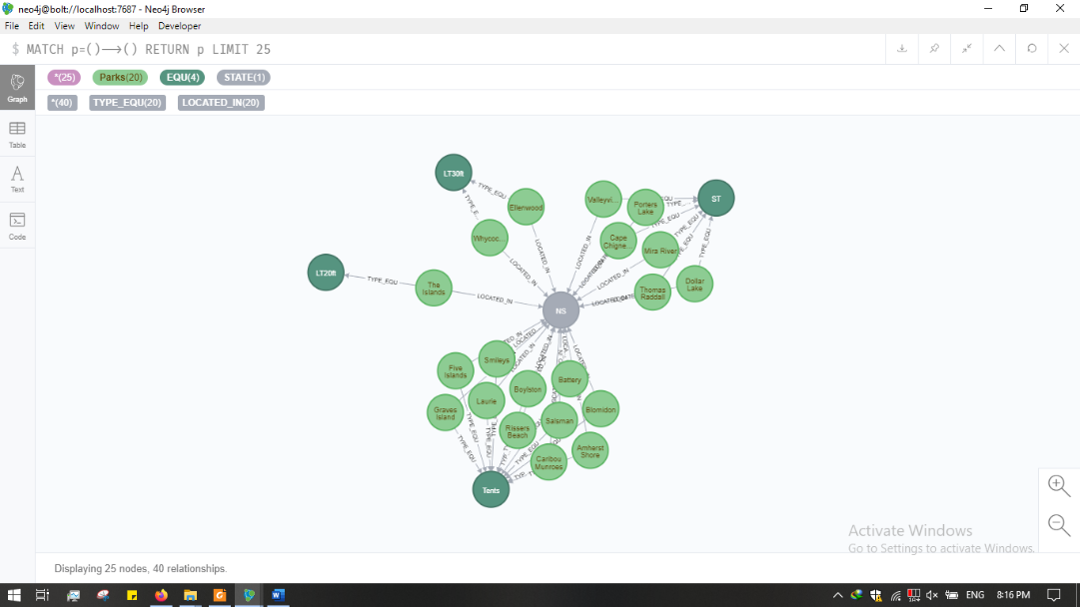

1. Create relationship between parks and bookingtype  
     
   Match (a:Parks),(b:Parks)  
   where a.BookingType = b.BOOKINGID   
   create (a)-[r:BOOKING_TYPE]->(b)  
   return r

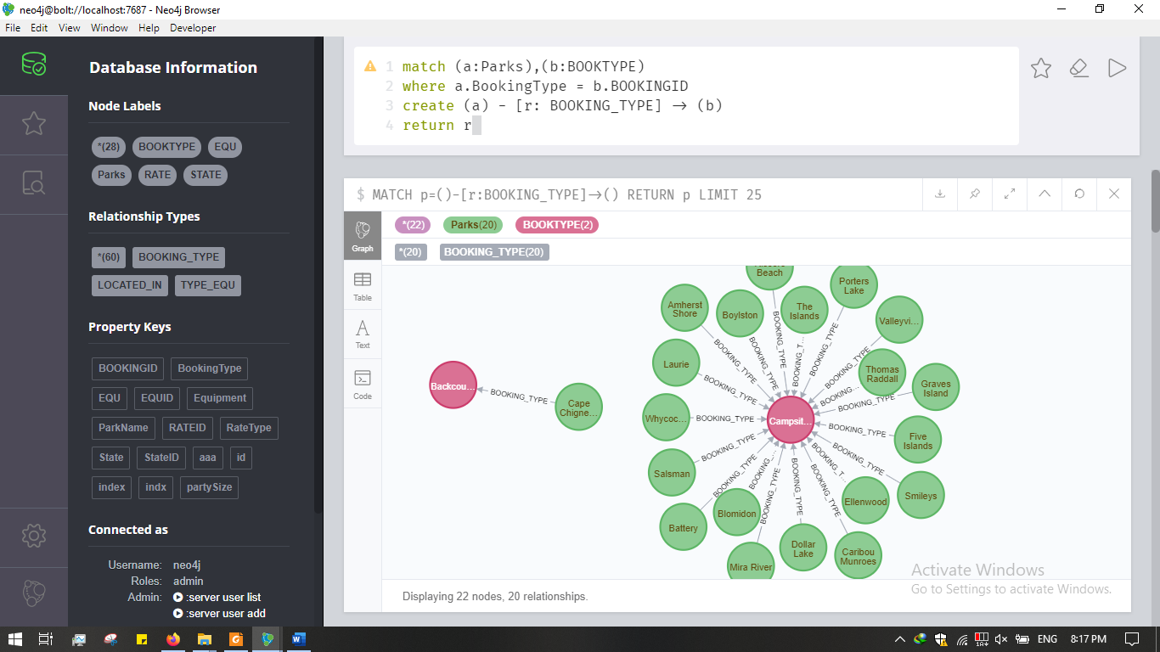

1. Create relationship between parks and ratetype  
     
   Match (a:Parks),(b:RATE)  
   where a.RateType = b.RATEID   
   create (a)-[r:BOOKING_TYPE]->(b)  
   return r

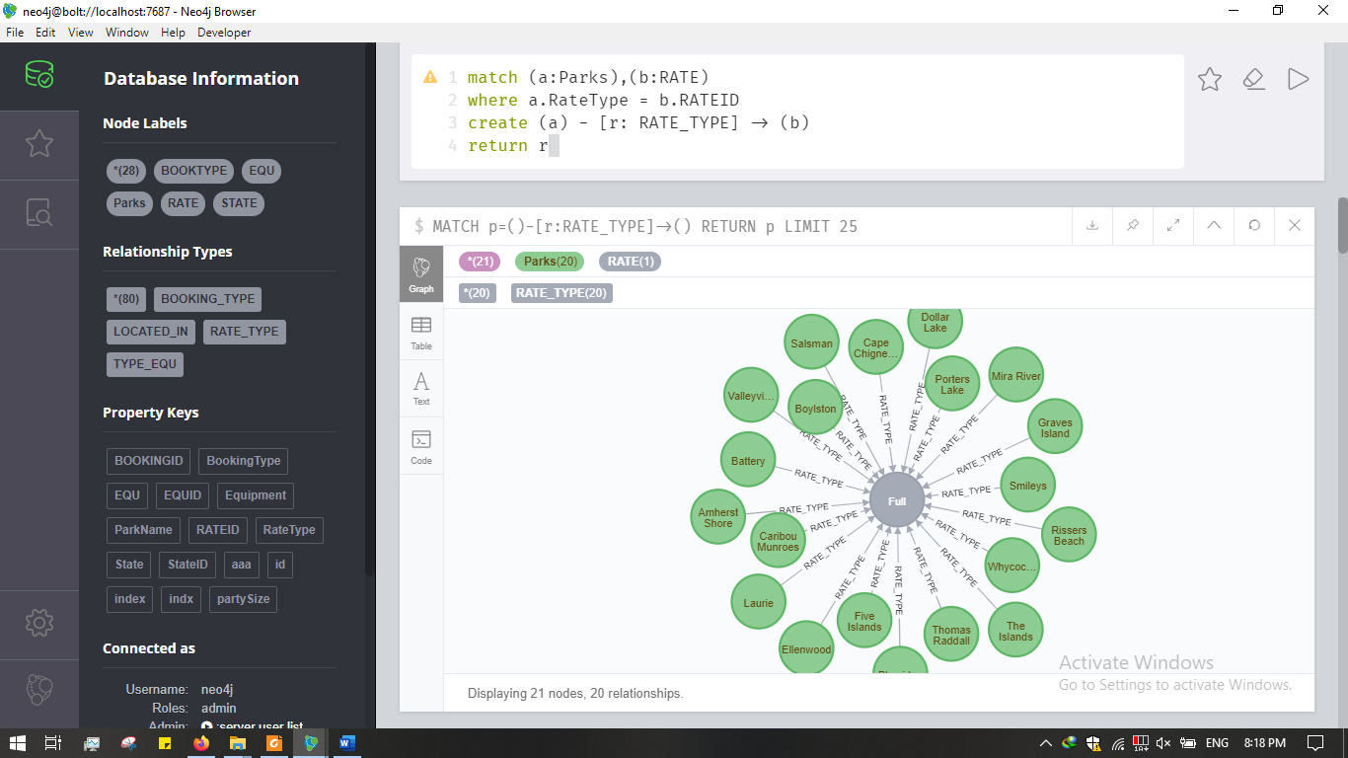

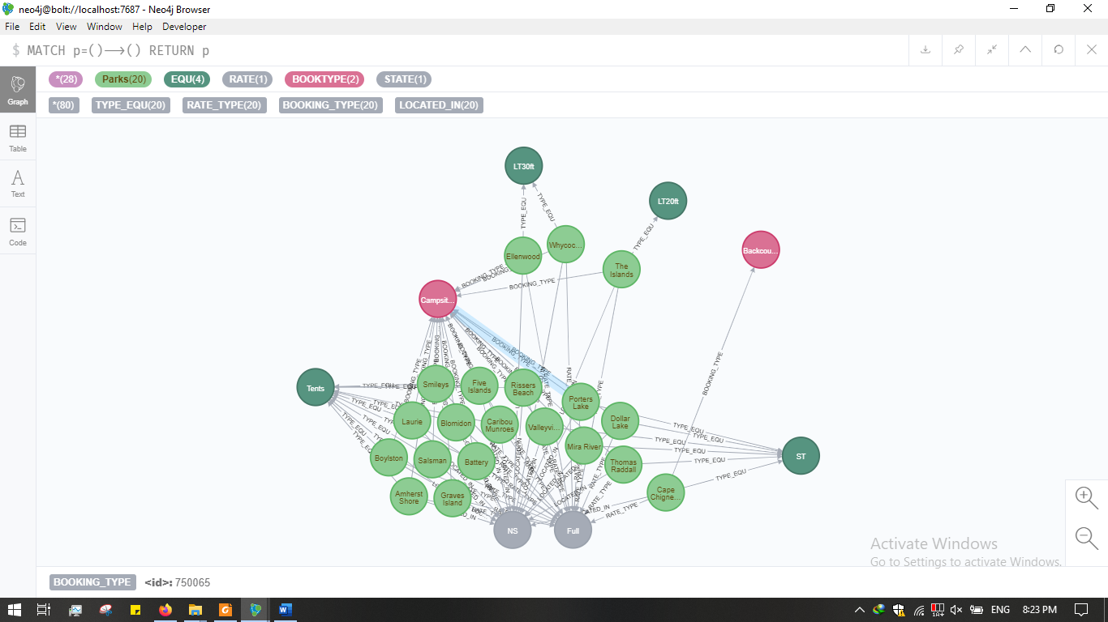

1. Find parkname having maximum partysize  
     
   match (xx: Parks)  
   with max(xx.PartySize) as found  
   match p=(a:Parks)🡪()  
   where a.PartySize=found  
   return p

